Analysis Report on Bicycle Theft in London Borough of Southwark

Hsin Hua Sung

**Analysis Report on Bicycle Theft in London Borough of Southwark**

**Introduction**

This report aims to assist Southwark Council to address the continuously increasing bicycle thefts in London Borough of Southwark (hereinafter referred to as Southwark) and promote cycling as a sustainable mode of transportation.

Southwark is an inner London borough situated on the south bank of the River Thames (Map 1), covering an area of about 28.85 km2. According to the 2011 Census, the total population was 288,283 (currently over 307,700).

To address the issue of bicycle theft, the locations for each recorded bicycle theft in London from December 2013 to November 2014 were provided as the basis for analysis. The following focuses on the hotspots, locations, trends, count and rates of bicycle theft, followed by a discussion of limitations and suggestions to provide practitioners with a reference for decision-making.

**

**Map 1** This map presents the 33 boroughs in London and the location of Borough of Southwark.

**Bicycle Theft Hotspots**

The data includes a total of 18,429 recorded bicycle theft offences in London. According to the statistics, Hackney, Westminster, Tower Hamlet, Camden, Lambeth, Islington, and Southwark had the most bicycle theft offences during this period. Southwark was ranked 7th (1075 offences) out of 33 London boroughs for bicycle thefts (Figure 1).

**Figure 1** This chart shows the count of bicycle thefts across 33 boroughs in London, with Southwark being the 7th-highest.

Nearest Neighbour Analysis (NNA) was performed to further examine whether there was spatial clustering in the distribution of bicycle thefts in London and Southwark. After calculation and border correction, the Nearest Neighbour Index (NNI) of bicycle theft offences in London was 0.41 (P-value = 0.0001). For bicycle thefts in Southwark, the Nearest Neighbour Index was 0.47 (P-value = 0.0001). These indicated that bicycle thefts were concentrated in specific areas both in London and Southwark, justifying the use of hotspot maps to present the distribution of offences (Map 2 and Map 3).

Four hotspots were identified from Southwark's hotspot map. Coupled with the location type (Map 4), possible reasons are analysed as follows:

**• Hotspot 1: London Bridge Station**

This area is close to the River Thames, surrounded by tourist attractions including Borough Market, The Shard, London Bridge, etc., which attracts large crowds. Moreover, this area is a commercial centre, bringing together enterprises and commercial buildings. Therefore, office workers who commuted by bicycle may be targeted here. It is worth noting that there were multiple bicycle thefts around London Bridge Hospital (Map 4).

**• Hotspot 2: Canada Water Station**

This area is close to Greenland Dock, with Canada Water Library, Deal Porter Square, and Surrey Quays Shopping Centre nearby. Bicycles that were not properly locked near the library, shopping areas and parking lots were vulnerable targets for theft.

**• Hotspot 3: Peckham Rye Station**

In addition to markets and supermarkets, this area is clustered with schools, parks, gyms, and theatres. Bicycles might be stolen when local students parked their bicycles around campus or when residents were engaged in leisure activities or shopping.

**• Hotspot 4: Camberwell**

Restaurants and supermarkets gather here, and as shown in Map 4, supermarkets had many bicycle theft records in this area. Residents may have their bicycles stolen while shopping for a short time.

**Map 2** This hotspots map shows the density of bicycle thefts in London, with higher density boroughs highlighted.

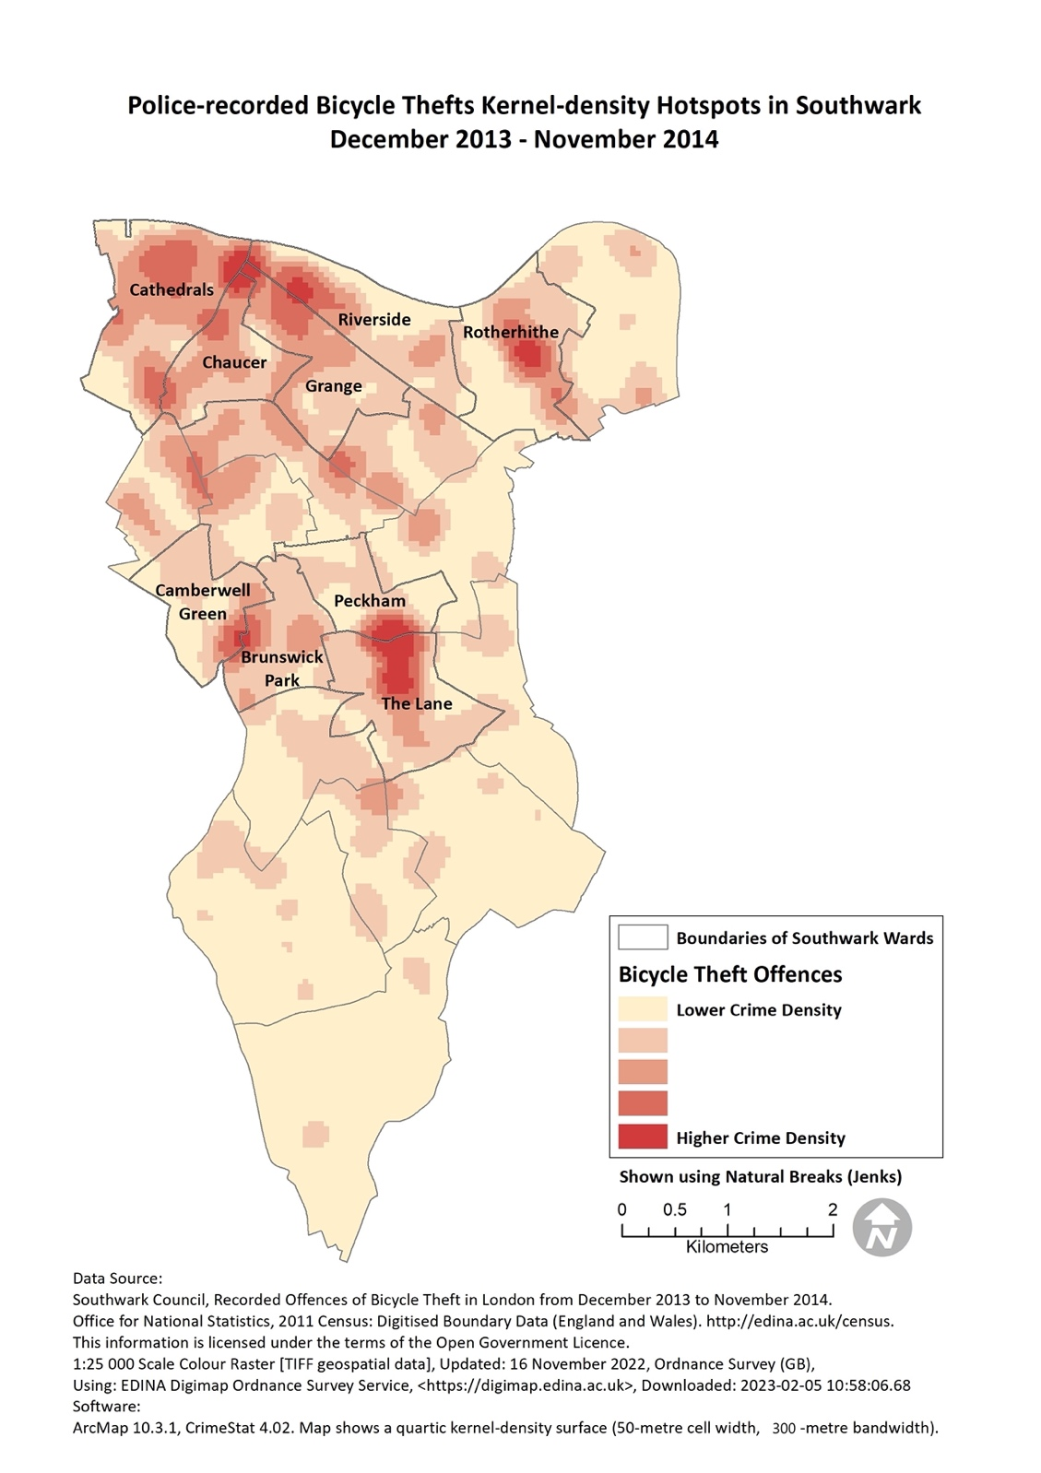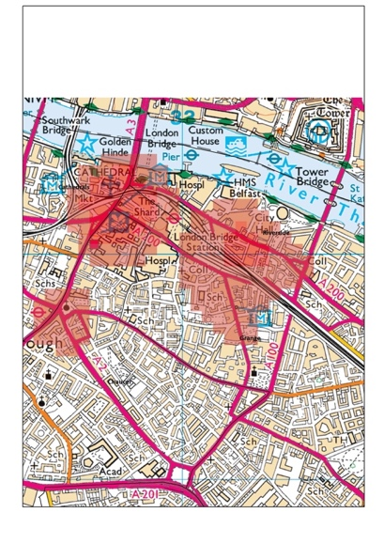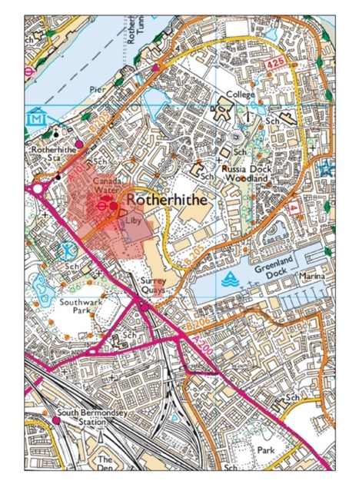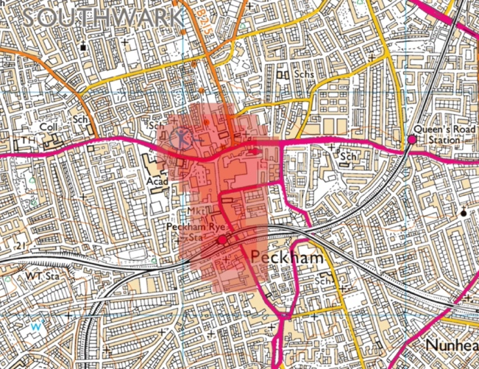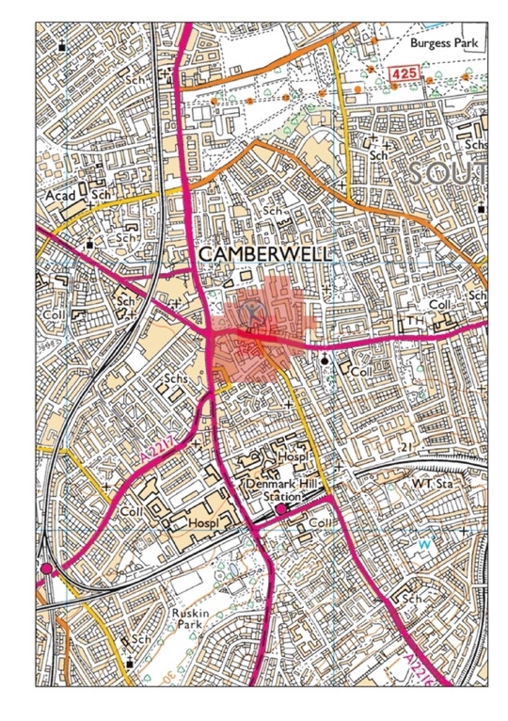

Hotspot 1

Hotspot 2

Hotspot 3

Hotspot 4

▼ Hotspot 1

▼ Hotspot 4

▼ Hotspot 3

▼ Hotspot 2

**Map 3** The hotspots map on the left displays the density of bicycle thefts in Southwark, with 4 hotspots highlighted and zoomed in on the right.

**Map 4** This map shows the location types of bicycle theft in Southwark.

The table on the right summarises the count of bicycle thefts in different locations, with the street being the most, followed by supermarkets and shopping areas.

**Bicycle Theft Trends**

The data of bicycle theft in this report is from December 2013 to November 2014 (a total of 12 months). As presented in Figure 2, there were 195, 222, 368 and 290 offences in Southwark in winter, spring, summer, and autumn respectively, showing that bicycle theft peaked in summer. This trend may stem from seasonal temperature changes, that is, residents tend to go out and travel in summer, whilst the number of bicycle users decreases in cold winter.

Through the thematic maps of bicycle thefts in the four seasons (Map 5), it can be found that Cathedrals was the area with the most bicycle thefts in winter and spring. Cathedrals and The Lane had the highest number of bicycle thefts in summer. As for autumn, there were more bicycle thefts in Cathedrals, Rotherhithe, and The Lane.

Map 6 divides the whole year into two halves, namely December to May (including winter and spring) and June to November (including summer and autumn). It can be seen that Cathedrals was the area with the most cases in the first half of the year. Cathedrals, The Lane, Riverside, and Rotherhithe had more bicycle thefts in the second half of the year.

**Figure 2** This chart shows the count of bicycle thefts in four seasons in Southwark, with summer being the peak.

|  |  |
| --- | --- |
|     **Map 5** The maps above illustrate the changes in bicycle thefts in Southwark in the four seasons. |  |
|  |  |

|  |  |
| --- | --- |
|     **Map 6** The maps above compare the bicycle thefts in Southwark in the first half of the year (left) and the second half of the year (right). |  |

**Table 1** This table summarises the count of bicycle thefts in each ward during different time periods.

The increase in the summer and second half of the year are calculated in the two columns on the right.

**Count of Bicycle Thefts in Different Time Frames in Wards in Southwark**

**Count of Bicycle Thefts**

Among the 21 wards in Southwark, Cathedrals, The Lane, Rotherhithe, Riverside, Chaucer, and Grange had the highest count of bicycle thefts during the period (Figure 3). These 6 wards accounted for 51.8% of bicycle thefts in Southwark. Among them, Cathedrals had the highest count of theft cases, with a total of 141 cases during the given time, which accounted for 13.1% of bicycle thefts in Southwark. From the time trend mentioned above, it can be found that Cathedrals was a hotspot throughout the year. Therefore, **limited funds could be prioritised for the neighbourhood policing team in Cathedrals ward, providing bicycle locks to local residents.**

**Figure 3** This chart demonstrates the count of bicycle thefts in wards in Southwark during the period.

|  |  |
| --- | --- |
|  |  |

**Map 7** The maps above show the count of bicycle thefts in wards (left) and output areas (right) in Southwark.

**Rate of Bicycle Thefts**

Given that each region has a different population, the count of crimes is not indicative of risk. Crime rates take the population into account, and the following two indicators were used to assess the risk of bicycle theft in each region:

1. **Population:**

The 2011 Census Data from the UK Data Service InFuse database was used to evaluate the risk of bicycle theft that each person may face based on the population of each ward. Whilst not everyone used a bicycle, considering population gave a better approximation of the real risk than the crime count. **Based on the population in each ward, Cathedrals had the highest risk of bicycle theft.** Further analysis with a smaller geographic unit, Output Areas, revealed internal high-risk hotspots (Map 8).

**Map 8** The maps above present the risk of bicycle thefts in wards (left) and output areas (right) in Southwark.

|  |  |
| --- | --- |
|  |  |

1. **Number of people who commuted by bicycle:**

Grasping the number of bicycle users helps to accurately calculate the risk of bicycle theft. 2011 Census Data also recorded ‘numbers and percentages of people in work aged 16-74 who travel to work by bicycle for all wards in London’. Although this data limits age, employment, and purpose of cycling, making it not representative of all bicycle users, it is still valuable as a benchmark to measure the number of bicycle users at that time. **Based on the number of people who commuted by bicycle, the high-risk areas for bicycle theft were Cathedrals and Rotherhithe** (Map 9).

**Map 9** The map displays the risk of bicycle thefts in wards in Southwark based on the number of people who travel to work by bicycle.

**CCTV**

CCTV has been proven to have the function of deterring criminals, strengthening surveillance, and collecting evidence. Map 10 presents the current distribution of CCTV cameras in Southwark. Overlaying with the hotspot map of bicycle thefts, it is found that the density of CCTV cameras at Hotspots 1 and 2 (London Bridge Station and Canada Water Station) is relatively low compared to other hotspots. This could be a reference for future intervention measures.

**Map 10** The maps above present the current distribution of CCTV cameras in Southwark (left) and an overlap with bicycle theft hotspots (right).

|  |  |
| --- | --- |
|  |  |

**Limitations**

The limitations mainly lie in two aspects:

1. Data limitations:

Based on recorded official data, there may be unreported or unrecorded dark figures. Additionally, there were time differences in the data in this report. For instance, the population was based on the 2011 Census, whilst it may have changed between 2013 and 2014 when the theft occurred. Third, the denominator used in the calculation of the crime rate did not represent the real population of bicycle users.

1. Map limitations:

The thematic maps are divided by administrative boundaries, which inevitably involves the Modifiable Area Unit Problem (Openshaw, 1984). That is, these boundaries are usually arbitrary and modifiable, and a slight change could result in a completely different map. Therefore, the data should be interpreted in conjunction with different types of maps and, where necessary, analysed across administrative boundaries.

Moreover, the classification method of the map can affect the presentation and interpretation. As shown in Map 11, the count of bicycle thefts in winter presented by natural breaks (Jenks) and equal interval are compared. Some wards are classified into different numerical intervals in the two maps, meaning that the maps alone may lead to different interpretations. Thus, maps should be supplemented with statistics and carefully interpreted to capture the whole picture.

**Map 11** The maps above display bicycle thefts in winter in Southwark with different classification methods, using Equal Interval on the left and Natural Breaks (Jenks) on the right.

|  |  |
| --- | --- |
| **Count of Bicycle Thefts in Winter in Southwark**  **December 2013 – February 2014**  **Classification Method: Equal Interval** | **Count of Bicycle Thefts in Winter in Southwark**  **December 2013 – February 2014**  **Classification Method: Natural Breaks (Jenks)** |
|  |  |

**Conclusion and Suggestion**

This report makes the following findings:

* London Bridge Station, Canada Water Station, Peckham Rye Station, and Camberwell were the hotspots of bicycle thefts in Southwark.
* Cathedrals had the highest number and rate of bicycle thefts among all wards.
* Bicycle theft reached its peak in the summer.
* The most common location type of bicycle theft was the street, followed by supermarkets and shopping areas.

Based on the above, it is expected that intervention measures targeting the hotspots will effectively reduce bicycle theft in Southwark. Streets were the dominant type of theft location, suggesting bicycle racks need to be installed universally. As for supermarkets and shopping areas, the government could impose responsibilities on private businesses. By encouraging companies to improve their surroundings or install more CCTV cameras, customers can be provided with safer bicycle parking. Additionally, the government should continue to guide citizens to take effective anti-theft measures. Whilst tackling crime hotspots, there is a need to monitor whether the displacement is occurring.

**References**

Openshaw, S. (1984). Concepts and Techniques in Modern Geography, Number 38. The Modifiable Areal Unit Problem. GeoBooks, Norwich, England.